# **Setting Up Mongo**

We can set up Mongo database server either on our machine locally or we can use cloud based free Mongo database server as a service from official mongodb.com

Mongo site - https://www.mongodb.com/

We will go with the later because it is easy to set up and doesn’t require much effort and easy to manage for now

Atlas site - <https://www.mongodb.com/atlas/database>

This is where we setup a free cloud based mongo for us

1. Click on Try Free
2. Sign up using Google Account or Email ID – Personal preferences
3. Create a new database and refer screenshots below for guidance

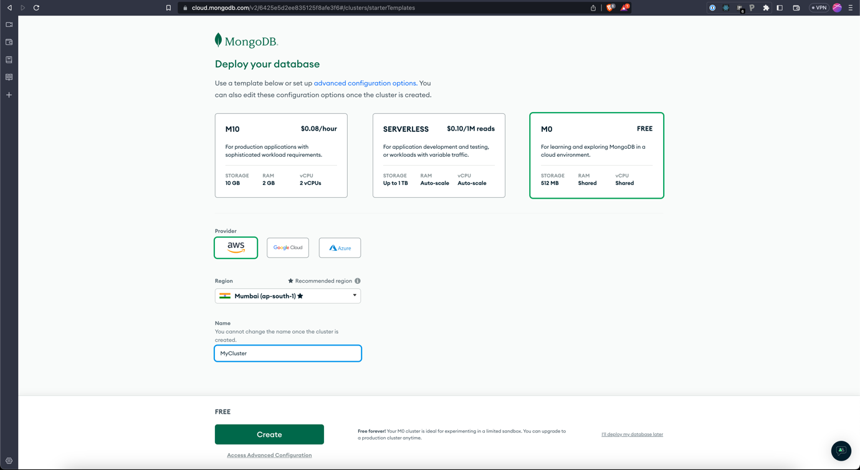

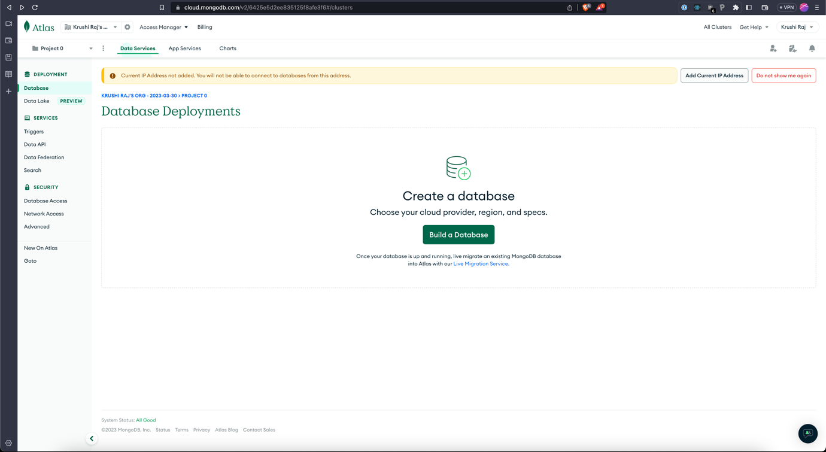

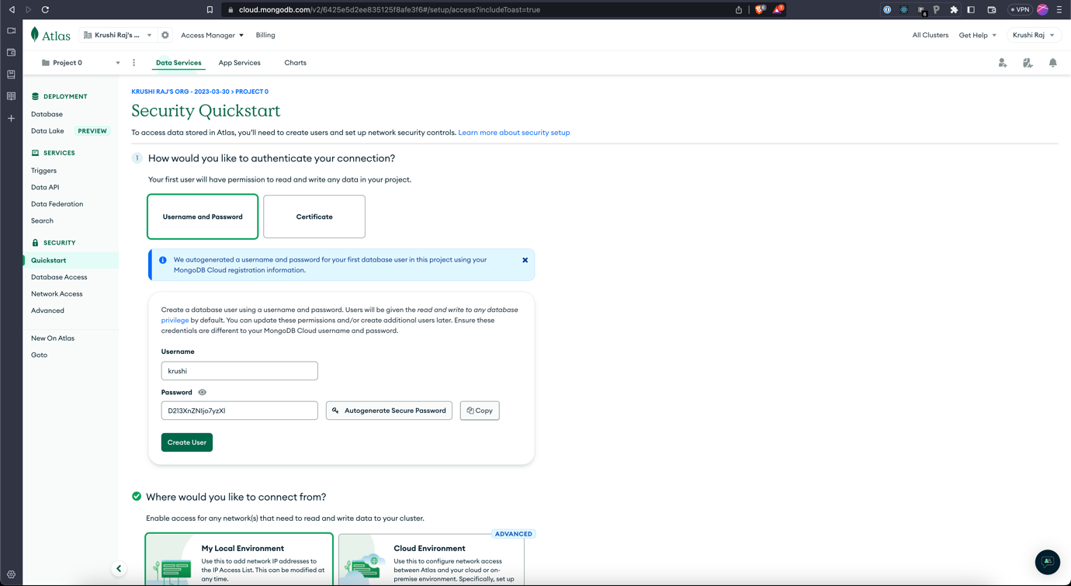

Create a user and make sure to save the password somewhere if you’re using auto generate password

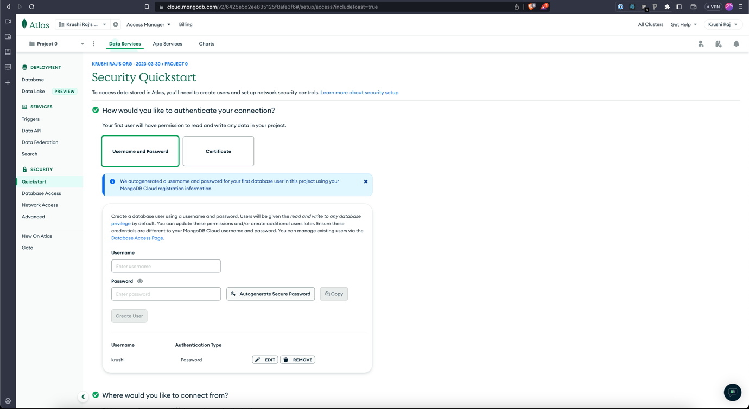

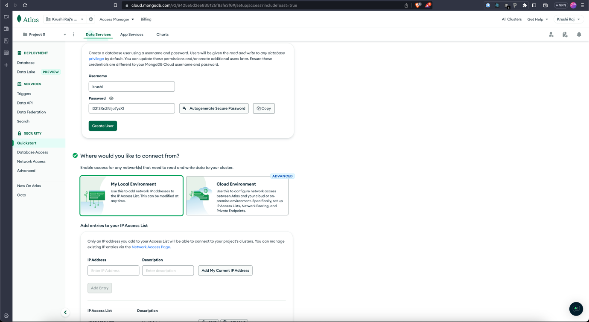

Click on Add My Current IP Address to allow access from your current machine’s IP. If you don’t do this you probably can’t access the DB from code on any machine

Alternatively, you can use 0.0.0.0 as IP address to allow access for everyone or any machine